

**Faculty of Engineering and Technology**

**Electrical and Computer Engineering**

**Department**

**Communication Laboratory**

**ENEE4113**

**Prelab Exp6 : Pulse Amplitude Modulation (Sampling)**

**Prepared by:**

Arwa Doha 11906324

**Instructor:** Dr.Ashraf Rimawi

**Assistant:** Eng.Mohammed Battat

**Section:** 6

**Date:** Nov 2, 2023

# Software Prelab

## Part 1: Generate a pulse train in Time and Frequency

#### Block Diagram: 🡪 using the pulse generator

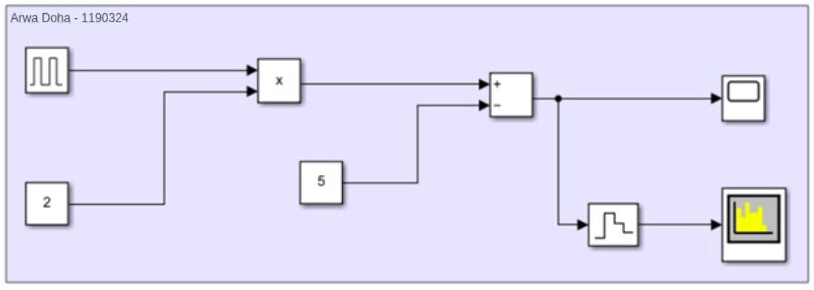

*Fig1: Block diagram of* *Generate a pulse train*

#### In time Doman:-

* We have discrete rectangular pulses.

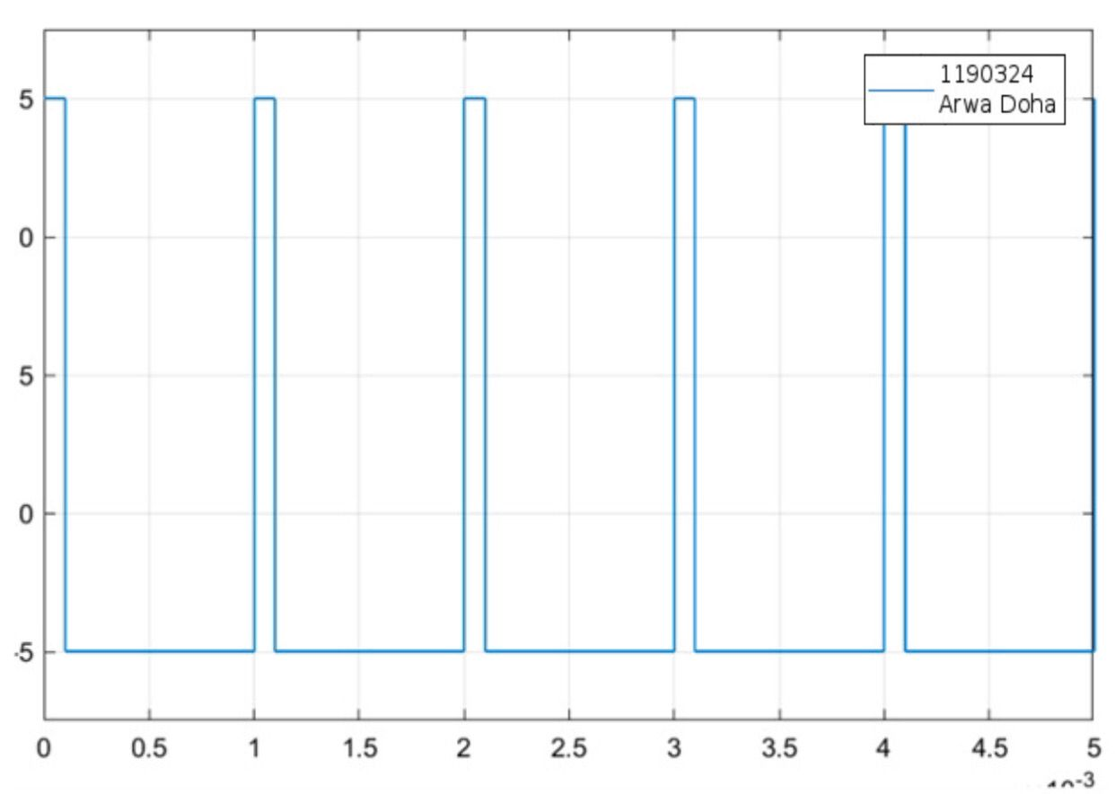

*Fig2: Time-Domain Representation of Pulse Train*

#### In Freq-Domain:

* We have series of impulse functions, and 1 kHz from impulse to another.

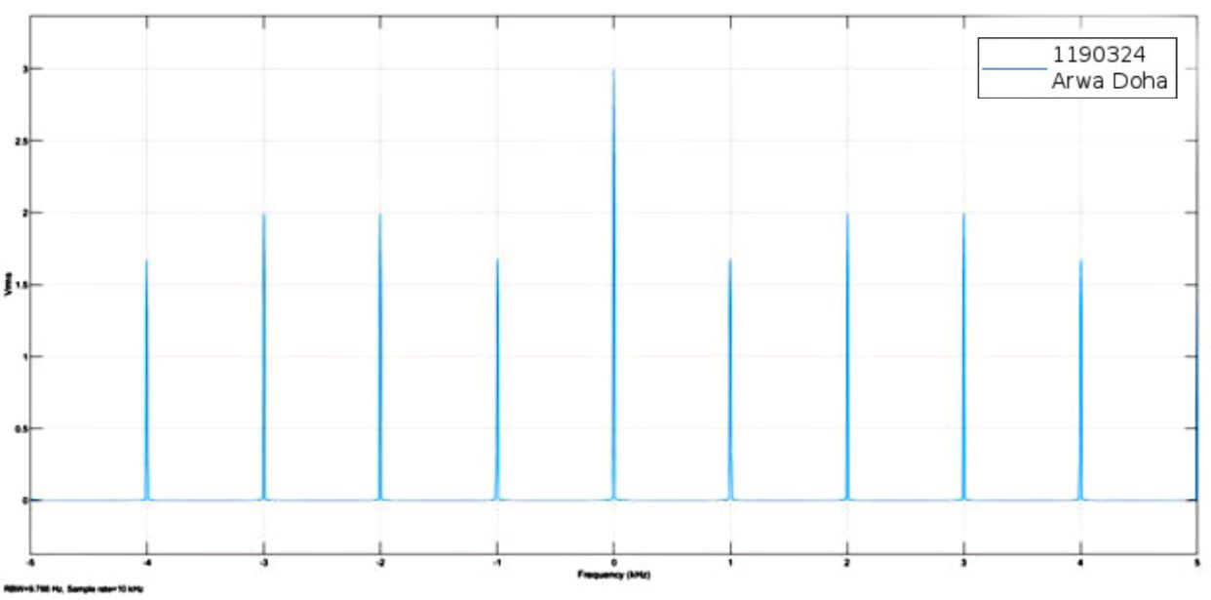

*Fig3: Freq-Domain Representation of Pulse Train*

* RBW= 9.766 , Sample rate =10KHz

## Part 2: Natural Sampling (PAM1) with demodulation

### 2.1 In this part we have characteristics of Pulse Amplitude Modulation.

#### Block Diagram:

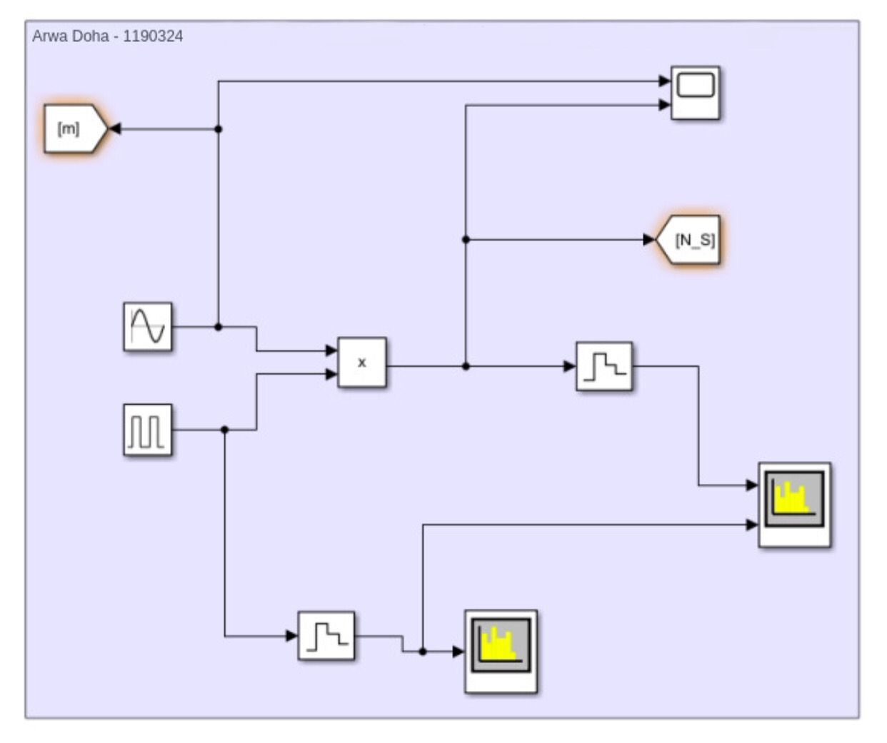

*Fig4: Block diagram of* *PAM1*

#### In Freq-Domain:

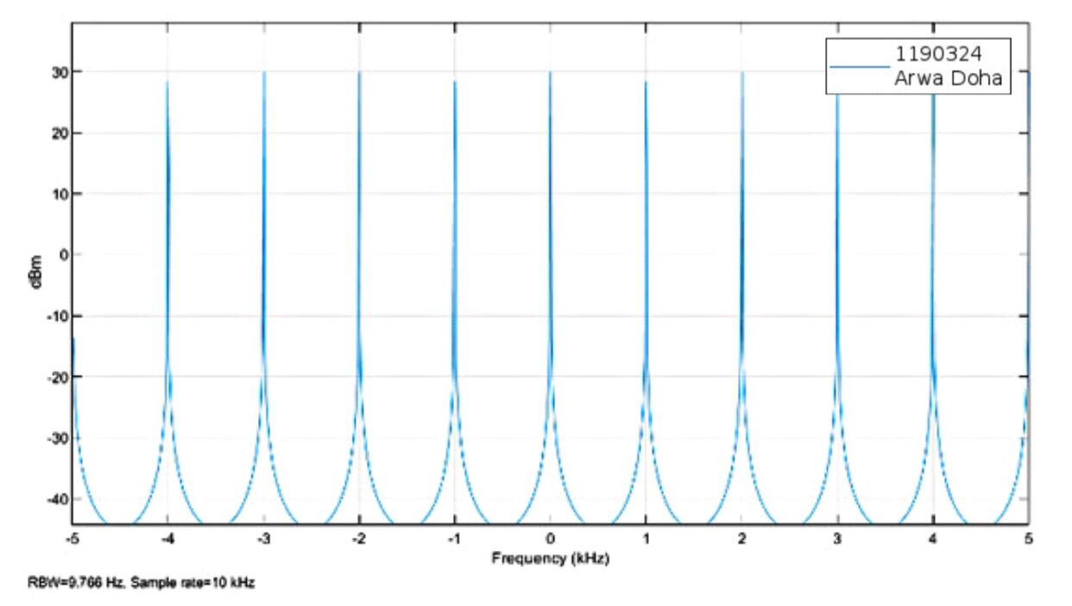

*Fig5: Freq-Domain of* *PAM1*

#### In time Doman:-

* Message signal and the sampled signal with duty cycle at 50

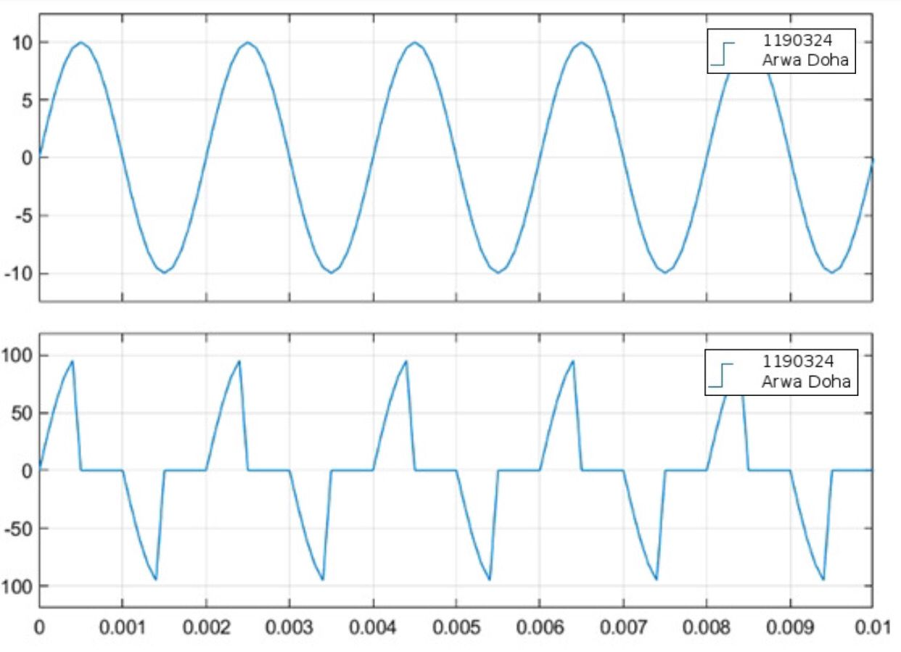

*Fig6: Time-Domain of* *message signal and the sampled signal with 50* *duty cycle*

* Message signal and the sampled signal with duty cycle at 10

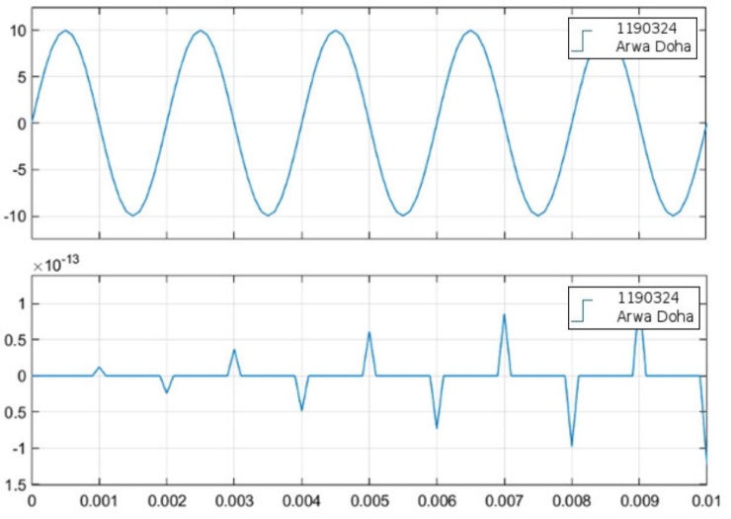

*Fig7: Time-Domain of* *message signal and the sampled signal with 10* *duty cycle*

### 2.2 Demodulation of Natural Sampling

#### Block Diagram:

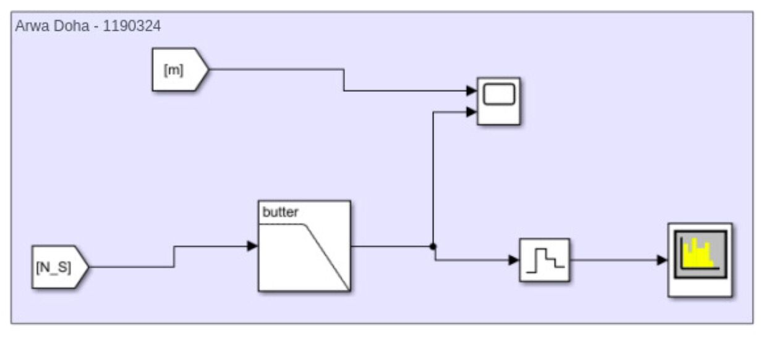

*Fig8: Block diagram of* *Demodulation of Natural Sampling*

#### In time Doman:-

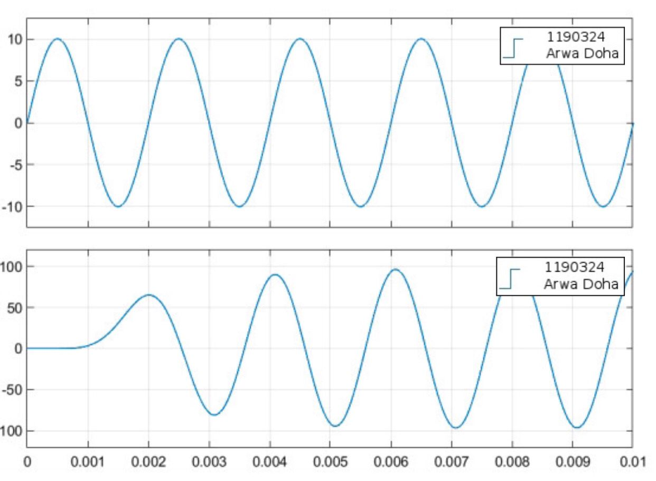

*Fig9: Demodulated Signal in Time Domain using Natural Sampling*

#### In Freq-Domain:

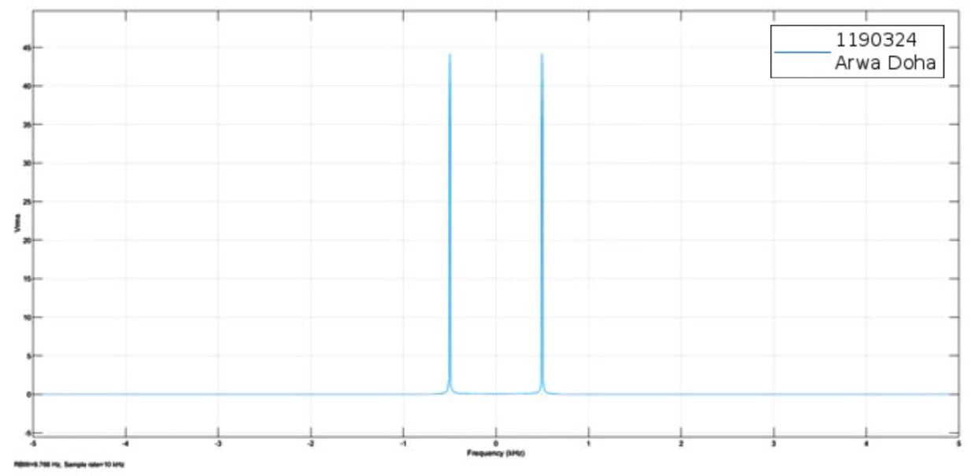

*Fig10: Freq-Domain Demodulated Signal using Natural Sampling*

Through the process of demodulation, we successfully recovered the original message signal operating at a frequency of 500Hz. By employing a low-pass filter , and as we note the frequency domain of demodulated signal in fig10 we note that dem-signal have the same freq of massage-signal.

## Part 3: Flat-top(Hold) Sampling (PAM2) with demodulation

#### Block Diagram:

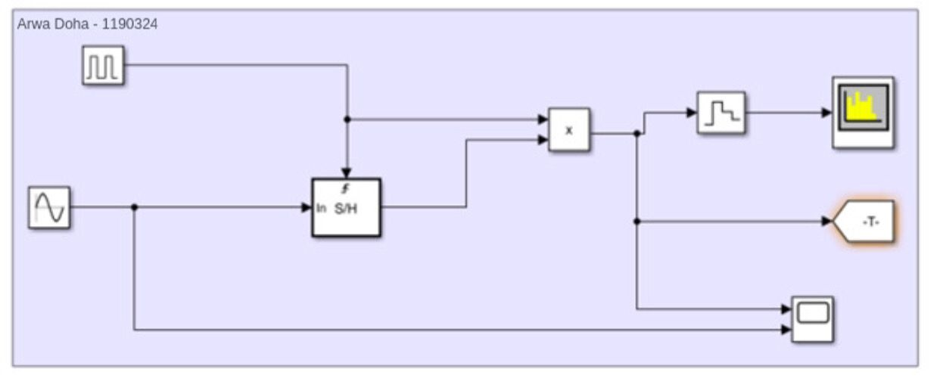

*Fig11: Block diagram of* *Flat-top Sampling (PAM2) with demodulation*

* 3.1 PAM2 with 10% duty cycle

#### In time Doman:-

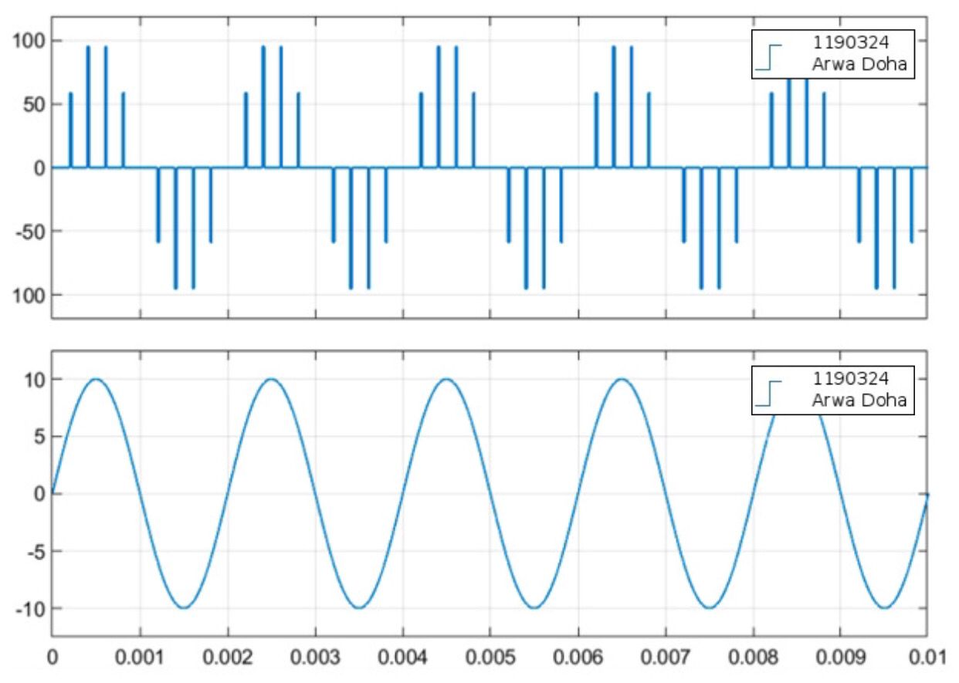

*Fig12: Sample and Hold Sampling in Time-Domain* *with 10% duty cycle*

#### In Freq-Domain:

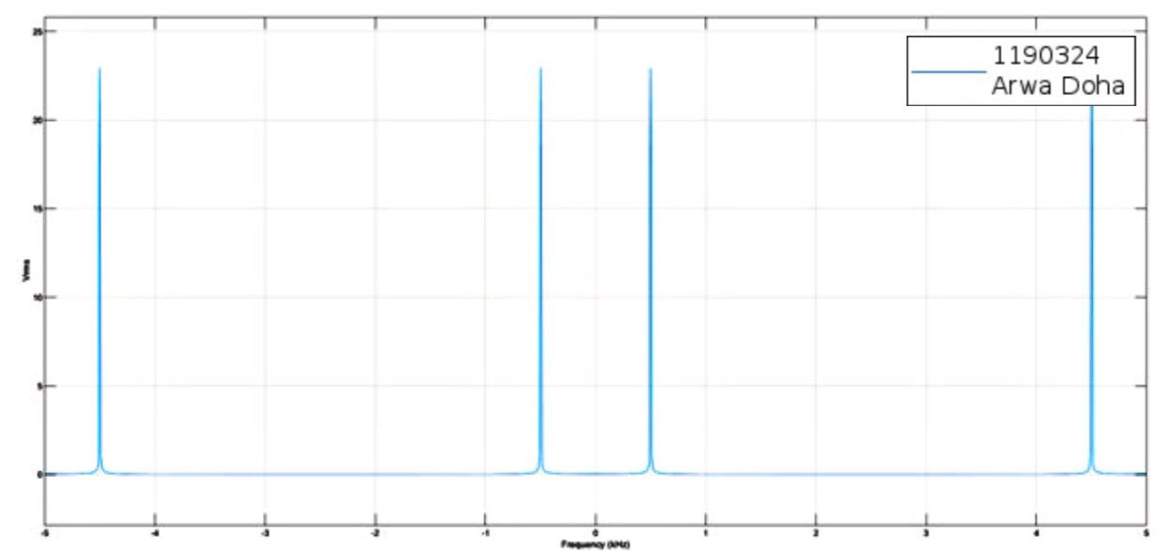

*Fig13: Freq-Domain with 10% duty cycle*

* 3.2 PAM2 with 30% duty cycle

#### In time Doman:-

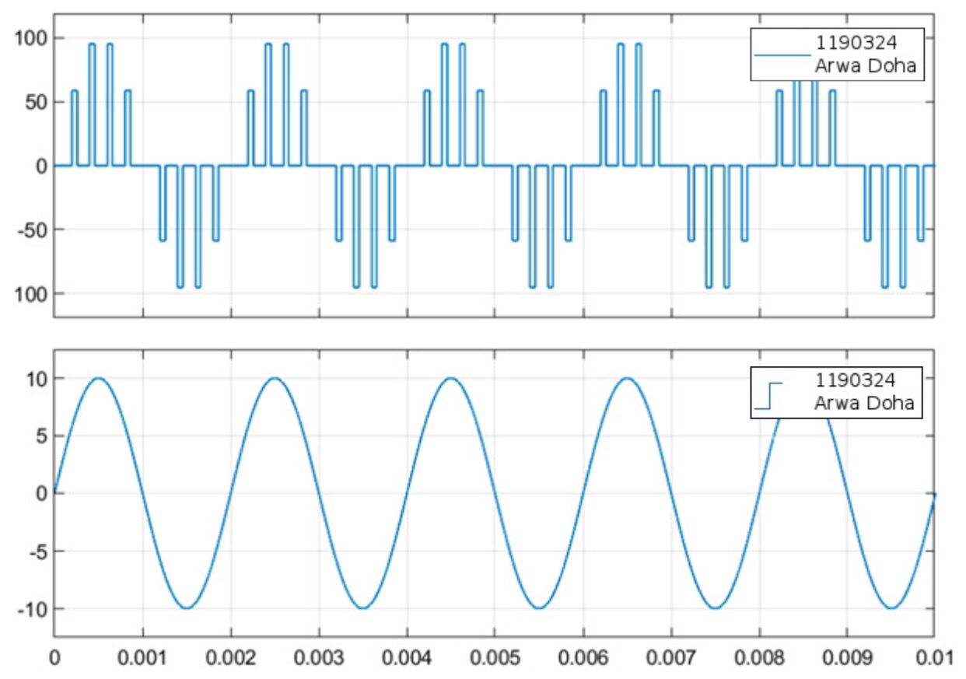

*Fig14: Sample and Hold Sampling in Time-Domain with 30% duty cycle*

#### In Freq-Domain:



*Fig15: Freq-Domain with 30% duty cycle*

## Part 4: Demodulation Natural Sampling

#### Block Diagram:

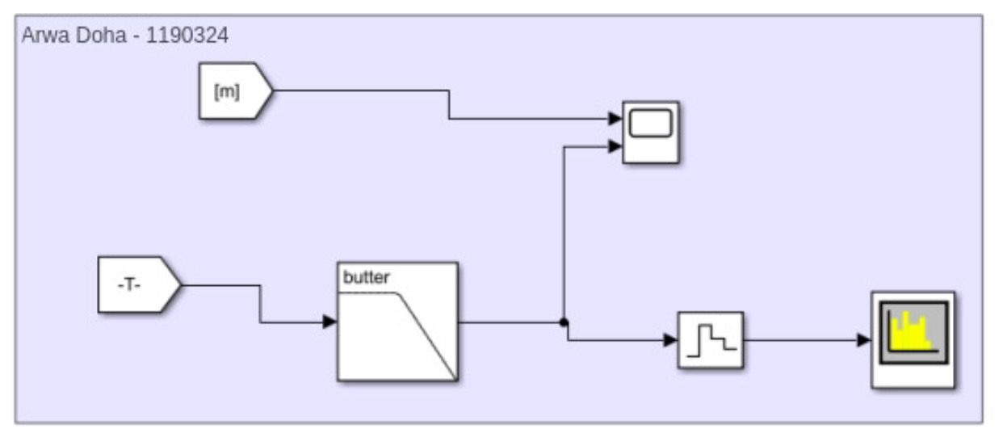

*Fig16: Block diagram of* *demodulation Natural Sampling*

#### In time Doman:-

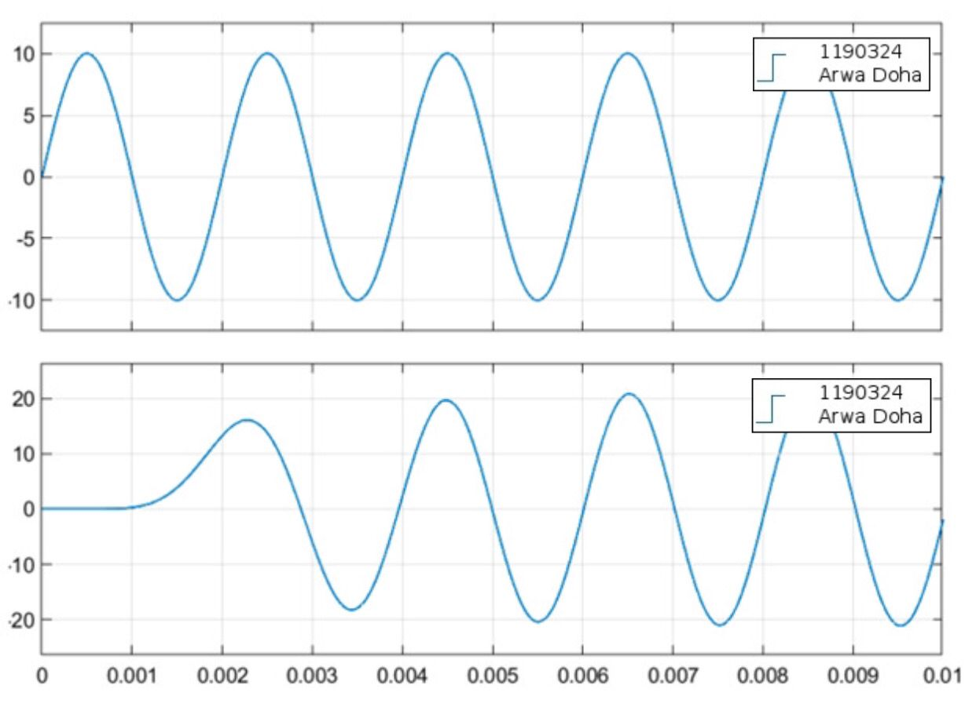

*Fig17: Time-Domain demodulation Natural Sampling*

#### In Freq-Domain:

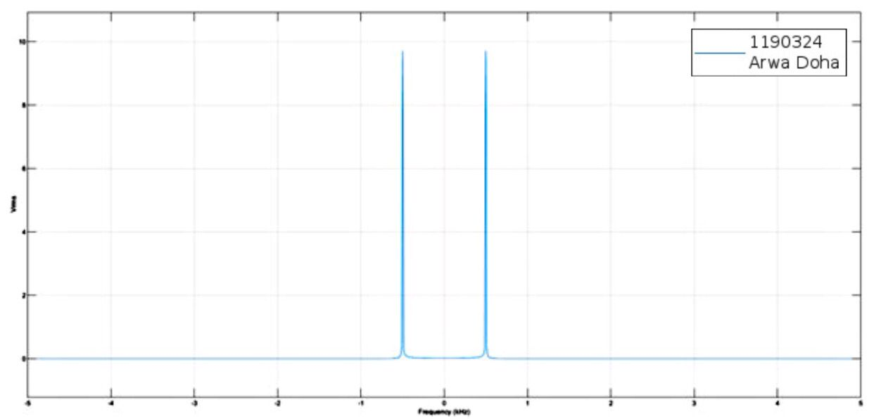

*Fig18: Freq-Domain demodulation Natural Sampling*

Much like the earlier demodulation process, employing a low-pass filter once again enables the successful retrieval of the message signal. In this instance, observing the frequency domain reveals the presence of two impulse functions at [500Hz & -500Hz], affirming the effectiveness of our demodulation process. This dual impulse pattern validates the accuracy 🡪 success of our demodulated output.